Initial Set up

This suit is designed to run on Windows using Chrome.

Although if you desire to run in on other OS, please modify the driver accordingly for each test suit.

Please change this line 12 of the .py files “AnyPage.py” and “TestSection2.py”.

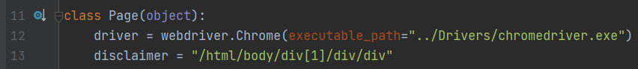



The drivers for MacOS, and Linux are included on the Drivers folder:

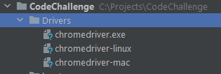

For example, for Mac:

self.driver = webdriver.Chrome(executable_path="../Drivers/chromedriver-mac")

Running the Program.

If you are using PyCharm, or similar, Got to “TestSection2.py”

Execute the MyTestSuit class:

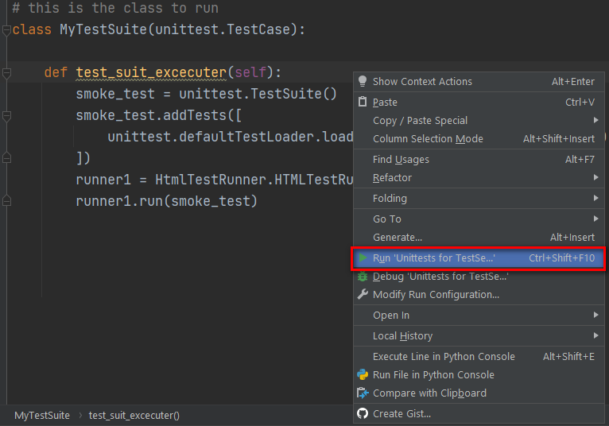

Once finished, this will generate a Report on the “Reports” folder of the project, easily identified by the date and timestamps on the filename:

